Phase 5 :

Day 1 : 03-09-2022

jUnit Testing : Phase 3 : jUnit5

Testing and development (devops)

TestNG

Selenium

Docker

CI and CD tool ie Jenkin

Overview of Kubernetes

Overview of AWS : Busket, EBS and EC2.

Test NG : Test NG is a open source testing framework inspired by jUnit and nUnit.

In Test NG ng means next generation. In Text Ng added more features.

Junit is to do unit testing

Test NG mainly use to testing for unit as well as integration testing.

1. Using Test NG we can generate the report in html or any other format.
2. It allow us to use parallel testing.
3. We can run group of test case as well as we can set the priority for the test.

TestNG Hook functions

Mock test with TestNG or jUnit5

Service layer always depends upon DAO layer

Dao layer depends upon resource layer

Resource layer depends upon database or external service.

Service layer want to do the mock or fake or proxy testing for Dao layer.

jMockito is a open source framework which help to provide the mocking mechanism.

Day 2 : 04-09-2022

UI (User Interface)

HTML, CSS, JavaScript,

jQuery

Angular Framework

React JS

Vue JS

Frontend technologies : JSP, html, css and JS

Jasmine : Jasmine is one of the type of open source framework which help to do the testing for JavaScript program.

Jasmine is like unit testing for JavaScript it may be plain JavaScript, typescript , Angular Framework etc.

Karma : Karma is runner for Jasmine framework.

Angular framework with Jasmine and Karma

React JS with JEST testing framework

Node JS + Jasmine or Mocha with Chai tools

Jasmine is like a jUnit

Mocha is like a TestNG

Selenium tool : Selenium is a type of open source automation tool which help to do the testing for UI.

It support for all browser, all os as well as lot of language like Java, Python, C#, Php, Perl etc.

Selenium provide web driver which help to test using Java, C# or python.

Selenium can be used to automation functionality test and can be integrate with other tools like Maven, Gradle, CI/CD ie Jenkin as well as Docker.

DevOps : Git, Maven, Gradle, Jenkin, Docker, Kubernetes, Agile etc

Automation testing tool can access the test data, control the execution of test and compared the actual result against the expected output.

Selenium provided Web Driver features which help to read or access the Web page contents.

Then we have the take the help of jUnit or TestNG API to check actual and expected output.

jUnit and TestNG they provided testsuite, test case and more than one assert method but they can’t load or access web page.

Selenium provided web driver which help to read or access web page content develop in any language.

Selenium with TestNG testing framework for UI testing using Java.

First we write simple Selenium Program to load the web page.

10-09-2022

Selenium with TestNG or jUnit 4.x or 5.x

105.0.1343.33

‘We can do the testing using selenium IDE.

11-09-2022

Docker is an advanced OS Virtualization software platform that makes it easier to create, deploy and run the application in Docker Container.

We can create Docker images

Virtualization : Virtualization means of employing software (such as hypervisor) to create a virtual version of resources such as database, tool, application etc.

Virtualization lets you divide a system into a series of separate section each one act as distinct individual system. That virtual environment is known as virtual machine.

VM ware

With help of VM ware software we can run multiple OS.

Base machine is window 11

RAM : 16 GM Guest OS as Linux or Unix

4GM to run Guest OS

But if we are planning to run more than on Guest OS 10 Guest OS.

Virtualization Vs Containerization

Virtualization is an abstract version of physical machine. Containerization means abstract version of an application. With help of Docker engine we can run the application in Docker container.

Container: run time environment or engine

Docker Container: This is a running process or instance or engine of an image or Running the instance of Docker image container turns the actual application or run the application.

Docker Image : it is a file system and configuration of our application or it is a template that hold a set of instruction which help to run the container.

Docker file : A Docker file is a blue print / set of instruction that defines how your image to build.

Demo.java

Docker commands

docker --version This command is use to find the Docker version

docker images This command is use to display all images present in current machine.

docker pull image-name This command is use to pull the image in local machine.

hello-world

docker run imageName/imageId This command is use to run the program.

Docker pull imageName : first it will search in image in Docker engine in local machine. if not present then it will pull from Docker hub

Docker hub is just like a Git hub responsible to publish as well as we can pull public images base upon our requirements.

Creating image to display simple message

Dockerfile

FROM busybox:latest

CMD ["echo","Welcome to My Busy Box Image"]

docker build -t my-busybox222 . -f Dockerfile this command is use to create the image

docker run my-busybox222 this command is use to run the image

creating image to display the date

Dockerfile

FROM alpine:latest

CMD [ "date" ]

docker build -t my-alpine222 . -f Dockerfile

docker run my-alpine222

Creating image to run the Simple Java program

Please create Java program

Dockerfile

FROM openjdk:11

#COPY *.java .

COPY com .

RUN javac -d . *.java

CMD [ "java","com.Demo" ]

docker build –t my-javaimage222 . –f Dockerfile

docker run my-javaimage222

Creating image to run the spring boot project

First create spring boot project.

Then create one or more rest api

Then using mvn command create the jar file

mvn package

Then create Dockerfile

FROM openjdk:11

COPY ./target/SpringBootWithRESTAPI-0.0.1-SNAPSHOT.jar .

CMD ["java","-jar","SpringBootWithRESTAPI-0.0.1-SNAPSHOT.jar"]

docker build -t my-spring-boot-app . -f Dockerfile

docker run -p 9090:9090 my-spring-boot-app

9090 : red port number actual port number

9090 : orange port number expose port number it can be same or different.

docker run -p 9090:9090 –d my-spring-boot-app

docker ps : This command is use to display all running container.

docker stop containerId/containerName

docker start containerId/containerName

to delete or remove container

first stop the container and then remove

or remove forcefully

docker rm containerId

or

docker rm containerId –f

UI (Frontend technology) to create the Image

First create html, css and js files

Then create Dockerfile

FROM nginx

COPY . /usr/share/nginx/html

docker build -t my-web-app . -f Dockerfile

by default tomcat port number 8080

by default nginx sever port number is 80

creating image to run the angular app

first create the project and verify it is running or not.

ng build : This command is use to build the project

after build you can see dist folder insider a angular project.

After build now you have to create Dockerfile

FROM nginx

COPY /dist/angular-with-docker/ /usr/share/nginx/html

Build the image

docker build -t my-angular-app . -f Dockerfile

nginx default port number 80.

docker run -p 82:80 -d a6104eba374b

Running mysql image

docker pull mysql:8

after pull we have start the server.

**docker run -e MYSQL_ROOT_PASSWORD=root -e MYSQL_DATABASE=mydb -p 3309:3306 -d 43fcfca0776d**

username is by default root.

Password we can give anything.

Now we have to open the image terminal

docker exec -it quirky_dubinsky bash

quirky_dubinsky : this is random image name

Then in image terminal we have to write

mysql -u root –p

password : root

**We push the image in docker hub . so other people can pull and run in their machine.**

docker push imageName

equested access to the resource is denied

docker login

docker push akashkale/my-angular-app

before push we have to create the tag for that image. Tag is like a version or identity for that image

generally we use tag as 1.0, 1.1, 1.2 or latest

docker tag my-angular-app akashkale/my-angular-app:1.0

docker push akashkale/my-angular-app:1.0

docker tag my-angular-app akashkale/my-angular-app:1.0

docker push akashkale/my-angular-app:2.0

docker-compose : it I use to run yml file which contains more than one container details which are communicate to each other to run the application.

Spring boot and mysql running

Image for Spring boot we have to pull the mysql

Assign username and password and database.

Network between two container which help communicate to each other and bridge.

Using docker command we have to create the network

Create the image for spring boot application and that application link the network environment.

Pull the mysql image and create username,password and database and run in network environment.

In application.properties file we have to provide the mysql image container details like host, username, and password.

And run both the images.

Or

Docker compose yml file. In this file we have to provide all image details, one image depends upon other image with network details and using docker compose command we have to run that file.

docker rmi imageId

docker rm containerId

18-09-2022

Spring boot application

mysql image with password and database name

first we have to create the network

docker network create spring-boot-mysql

here spring-boot-mysql is a network name.

to view the network

docker network ls

now we will pull mysql image

docker pull mysql:8

This command is use to run the container with name with network with password and databasename

docker run --name=mysqldb --network=spring-boot-mysql -e MYSQL_ROOT_PASSWORD=root -e MYSQL_DATABASE=mydb -p 3307:3306 -d mysql:8

open container’s os terminal

exec -it mysqldb bash

to connect the database we have to use the command as

mysql –u root –p

* root

now we have to create the spring boot application with rest api connected with database

then create jar file using mvn package command.

Plz open the command prompt inside a spring project mainly (in place where pom.xml file present).

Then run

mvn package

if we create spring boot project using spring initializer. By default they have added testing starter. So when we do mvn package internally testing file execute that file trying to connect the database.

So please remove testing dependencies and testing file then run mvn package command once again

mvn package

now you can create the Dockerfile

**FROM** openjdk:11

**COPY** /target/spring-boot-docker.jar .

**CMD** ["java","-jar","spring-boot-docker.jar"]

docker build –t spring-boot-app . –f Dockerfile

docker run --name=spring-boot-app --network=spring-boot-mysql -p 9090:9090 -d spring-boot-app

name 🡪 container name

network 🡪 network name

spring.datasource.driver-class-name=com.mysql.cj.jdbc.Driver

spring.datasource.url=jdbc:mysql://mysqldb/mydb

spring.datasource.username=root

spring.datasource.password=root

spring.datasource.initialization-mode=always

spring.jpa.hibernate.ddl-auto=create

server.port=9090

Docker compose : Docker compose is a tool which help to defined more one contains details and share multi contains details. With docker compose we can define these all container details in yml file and using Docker compose command we can up, down, build etc.

Swarm

Kubernetes

Both are known as container management tools.

It is use to run more than one container like 10 to 100 container interacting with each other may be running in same node or different node(machine).

CI and CD tools :

Continues integration and Continues delivery/ deployment

Team1

Coding

Team2 Git (remote repository) : we have to build the project

Coding may we will get the error or

It build successfully.

Team3

Coding

Build phase : compile, run, creating, jar, war or ear, testing file

We will configure CI and CD tool with Sub version control system like GIT. Whenever any person push the code in remote repository in main/master or user –defined branch. CI and CD tool pull the code from git and build it. Build phase done successfully this code they can pass to next team or product environment or testing server. If anything wrong in that code tool will send the notification to respective team.

Jenkins: it is open source ci and cd tool created using Java technologies. It is plugin base ci and cd tool.

**To use Jenkins**

1. **We have to install Jenkins software**
2. **We have to download war and run that war file using tomcat or any web server.**
3. **We can use Docker.**

**24-09-2022**

Jenkin pipeline : Jenkin pipe is a collection of jobs which are interlinked with one another in a sequence.

Verify all environment and version of the application

We download the dependencies

We compile project

We test project

If we want to run more than one container like 100 or 50 and those container running different machine or Node.

Container management tool

Kubernetes and Docker swarm

Spring micro service

Monolithic Vs Micro Service

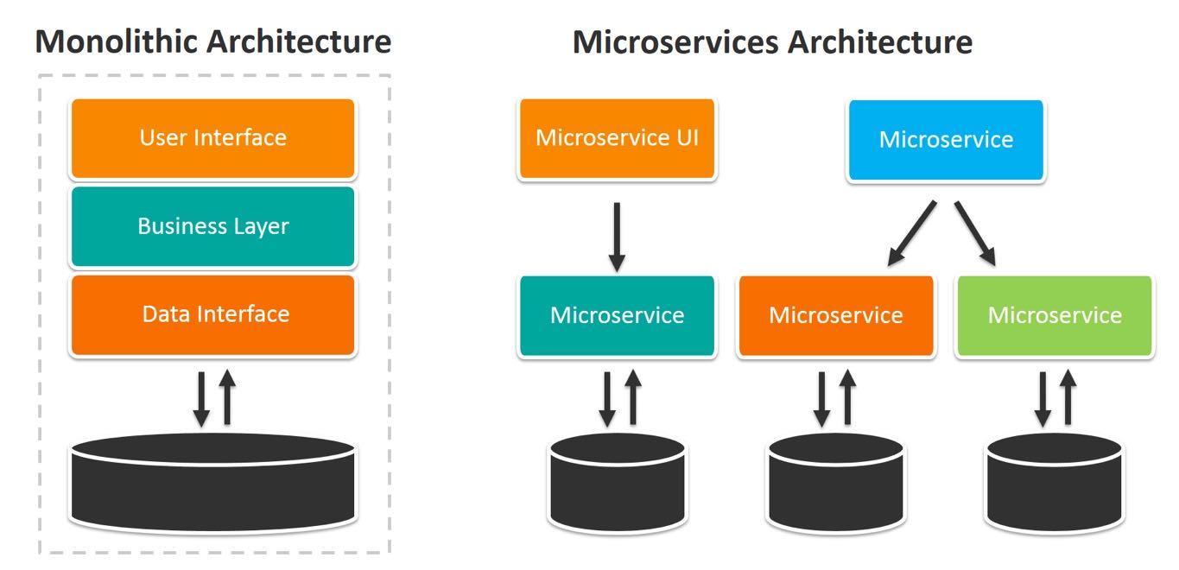

In micro service : small service rest api : we can develop using any language with same different database and we can deploy independently.

Spring boot provided pre defined open source ie Eureka which behave like a server which help to maintain more than one micro service develop using spring boot.